WATER QUALITY ANALYSIS

**Objectives**

The objective is to evaluate the extent of water pollution and its implications for both public health and the environment. This is achieved through a thorough examination of water quality, involving tests to identify various contaminants, analyze chemical composition, and detect microbial presence. The goal is to gather detailed information about the water's condition, enabling the development of targeted approaches for water treatment and conservation. By conducting this analysis, informed decisions can be made to mitigate pollution, safeguard public health, and preserve the natural environment.

**DESIGN THINKING PROCESS**

1. **Empathize:**
   * **Understand Stakeholders:** Identify and empathize with the stakeholders involved, including communities relying on the water source, environmental agencies, and policymakers. Understand their concerns, needs, and expectations regarding water quality.
   * **Field Observations:** Visit the water source and observe the surrounding environment. Understand the context in which the water quality analysis is conducted.
2. **Define:**
   * **Problem Definition:** Clearly define the problem related to water quality. It could be pollution, declining water levels, or specific contaminants affecting human health. Define the problem in a way that is actionable and understandable.
3. **Ideate:**
   * **Brainstorm Solutions:** Encourage multidisciplinary teams to brainstorm potential solutions to the defined problem. Explore innovative technologies, community engagement strategies, and policy interventions.
   * **Encourage Creativity:** Foster a creative environment where unconventional ideas are welcomed. Encourage team members to think outside the box and consider novel approaches to water quality analysis and improvement.
4. **Prototype:**
   * **Develop Prototypes:** Create prototypes of the proposed solutions. These could include pilot water treatment systems, community awareness campaigns, or data visualization tools. Prototypes should be tangible enough to convey the concept clearly.
   * **Iterative Prototyping:** Iterate on the prototypes based on feedback. Continuously refine and improve the prototypes based on insights gained from initial testing and user feedback.
5. **Test:**
   * **Implement Pilots:** Implement the prototypes in real-world settings, such as specific communities or water sources. Monitor the effectiveness of the prototypes in addressing the water quality issue.
   * **Gather Feedback:** Collect feedback from stakeholders and users. Understand how well the implemented solutions meet their needs and expectations.
   * **Iterate and Refine:** Based on feedback, iterate on the prototypes. Make necessary adjustments and refinements to improve the effectiveness and usability of the solutions.
6. **Implement:**
   * **Scale Up:** Once a viable solution is identified and refined through testing and iterations, develop a plan to scale up the solution. This could involve implementing the solution across larger communities or water systems.
   * **Collaborate:** Collaborate with relevant organizations, government agencies, and communities to implement the solution effectively. Ensure that resources and expertise are leveraged for successful implementation.
7. **Learn:**
   * **Reflect and Learn:** Reflect on the entire design thinking process. Identify lessons learned, challenges faced, and successes achieved. Document these insights for future reference.
   * **Share Knowledge:** Share the knowledge and experiences gained during the process. Contribute to the broader scientific and environmental community by publishing findings, best practices, and successful methodologies.

**DEVELOPMENT PHASES:**

1. **Problem Definition and Planning:**
   * **Identify Objectives:** Clearly define the objectives of the water quality analysis. Determine what specific parameters need to be tested and the purpose of the analysis (e.g., assessing drinking water safety, evaluating environmental impact).
   * **Study Area Selection:** Determine the geographical area or specific water sources to be analyzed.
   * **Sampling Design:** Develop a sampling plan, including the selection of sampling points, frequency of sampling, and methods of sample collection. Ensure that the sampling plan is representative of the area under study.
2. **Data Collection:**
   * **Sample Collection:** Collect water samples according to the established sampling plan. Use proper sampling techniques to avoid contamination and ensure sample integrity.
   * **Field Measurements:** Conduct on-site measurements for parameters such as temperature, pH, turbidity, and dissolved oxygen. Record these measurements accurately.
   * **Preservation and Transportation:** Preserve samples appropriately to prevent changes in their chemical composition during transportation to the laboratory. Follow standard protocols for sample preservation.
3. **Laboratory Analysis:**
   * **Sample Processing:** Prepare samples for analysis, including filtration, dilution, or other necessary procedures.
   * **Chemical Analysis:** Perform chemical tests to determine the concentration of various contaminants, including heavy metals, nutrients, organic pollutants, and other chemical constituents.
   * **Microbiological Analysis:** Conduct tests to identify and quantify bacteria, viruses, and other microorganisms present in the water samples.
   * **Quality Control:** Implement quality control measures to ensure the accuracy and reliability of laboratory results. This includes calibration of instruments, use of certified reference materials, and adherence to standardized methods.
4. **Data Analysis and Interpretation:**
   * **Comparison with Standards:** Compare the obtained results with established water quality standards and guidelines. Determine if the water quality meets the required criteria for safe consumption or environmental health.
   * **Data Interpretation:** Analyze the data to identify trends, patterns, and potential sources of contamination. Interpret the findings in the context of the study objectives and the impact on human health and the environment.
5. **Reporting and Communication:**
   * **Report Preparation:** Compile the analysis results, interpretations, and conclusions into a comprehensive report. Include details about the sampling process, laboratory methods, results, and recommendations.
   * **Visualization:** Use graphs, charts, and maps to visualize the data effectively. Clear visual representation can aid in understanding complex water quality information.
   * **Communication:** Present the findings to stakeholders, policymakers, and the public in a clear and understandable manner. Effective communication is crucial for raising awareness and informing decision-making processes.
6. **Recommendations and Action:**
   * **Recommendations:** Based on the analysis and interpretation, provide recommendations for actions. This could include suggesting water treatment methods, implementing pollution control measures, or regulatory changes.
   * **Implementation:** Collaborate with relevant authorities and organizations to implement the recommended actions. Monitor the progress of implemented measures and assess their effectiveness in improving water quality.
7. **Continuous Monitoring and Review:**
   * **Long-term Monitoring:** Establish a system for continuous monitoring of water quality parameters to track changes over time.
   * **Review and Adaptation:** Periodically review the monitoring methods and adapt them to evolving scientific standards and technological advancements. Stay updated with new research findings and adjust monitoring strategies accordingly.

**DATA PRE-PROCESSING**

Data preprocessing involves preparing raw data for analysis by cleaning, transforming, and reducing its complexity. It includes handling missing values, detecting outliers, scaling numerical variables, encoding categorical data, and reducing dimensions. Data preprocessing enhances data quality, making it suitable for accurate analysis and modeling.

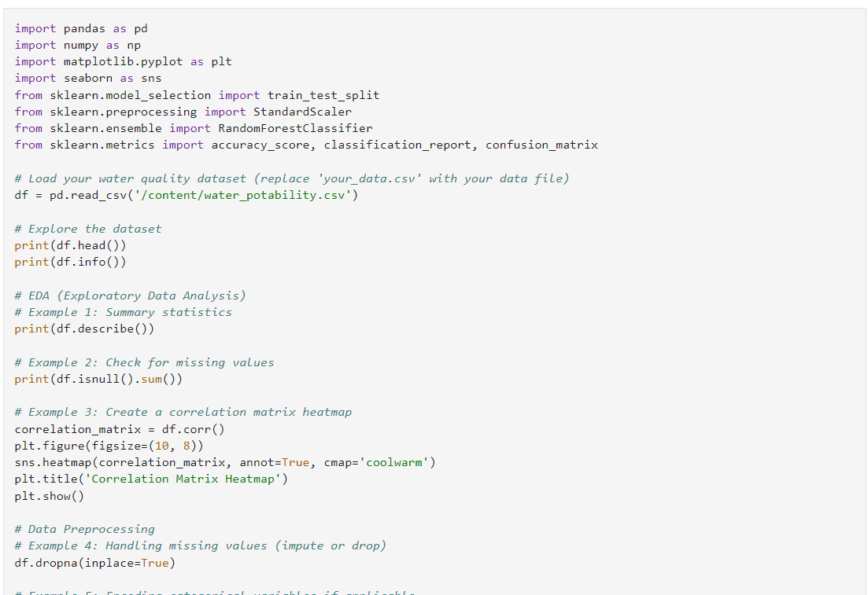

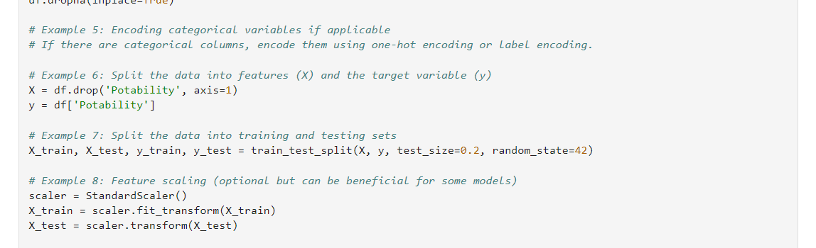

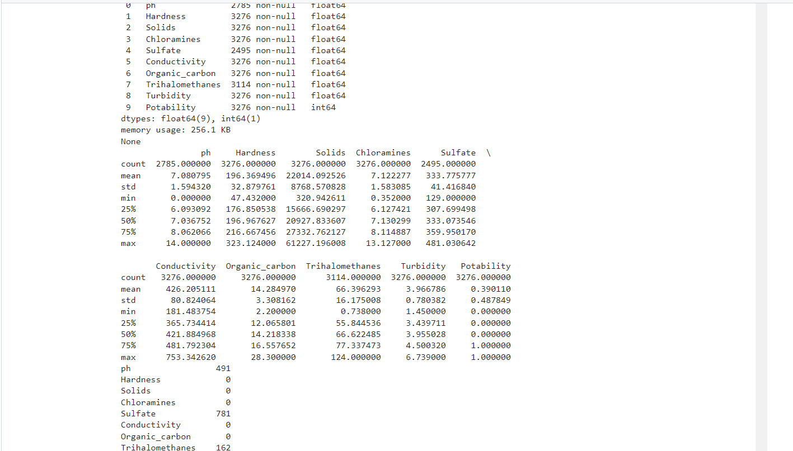

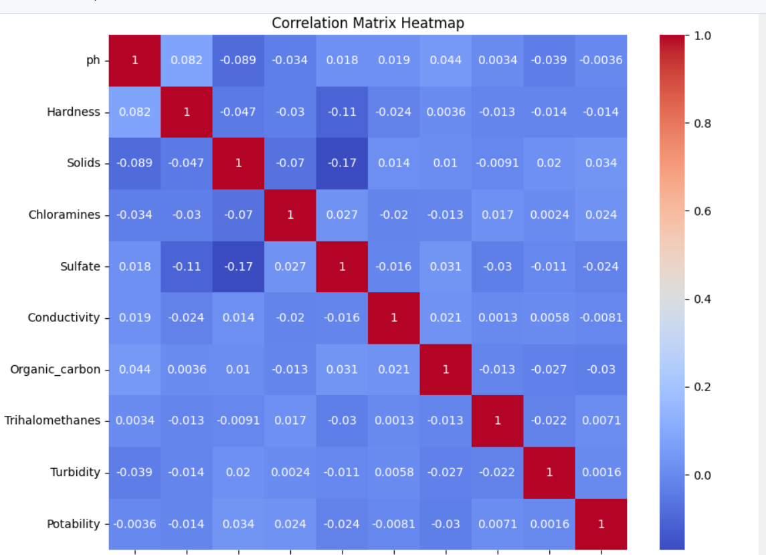

**EXLORATORY DATA ANALYSIS**

Exploratory Data Analysis (EDA) is a critical phase in data analysis, where data analysts or scientists examine and visualize data to gain insights, identify patterns, and understand its underlying structure. The primary goals of EDA are as follows:

1. **Data Summarization:** EDA involves obtaining a summary of the main characteristics of the data, which includes basic statistics (mean, median, standard deviation, etc.) and key properties of variables.
2. **Data Visualization:** Analysts use various graphical and visual tools, such as histograms, box plots, scatter plots, and bar charts, to visually represent the data. This allows for a better understanding of data distributions, trends, and anomalies.
3. **Pattern Identification:** EDA helps uncover patterns and relationships within the data. Analysts look for trends, correlations, and outliers that can inform subsequent analyses or hypotheses.
4. **Data Cleaning:** During EDA, data cleaning tasks, such as handling missing values and outliers, are often addressed to ensure the data's reliability and integrity.
5. **Hypothesis Generation:** EDA often leads to the formation of hypotheses that can be tested in later stages of the analysis. These hypotheses arise from observations made during data exploration.
6. **Feature Selection:** EDA can assist in identifying which features (variables) are most relevant for analysis and modeling, potentially reducing dimensionality.

EDA is an iterative process, and it can be conducted using various statistical and visualization tools. Its results help guide subsequent analytical steps, such as predictive modeling or hypothesis testing. EDA is a crucial phase in the data analysis pipeline as it aids in understanding data quality, revealing data storylines, and facilitating informed decision-making.

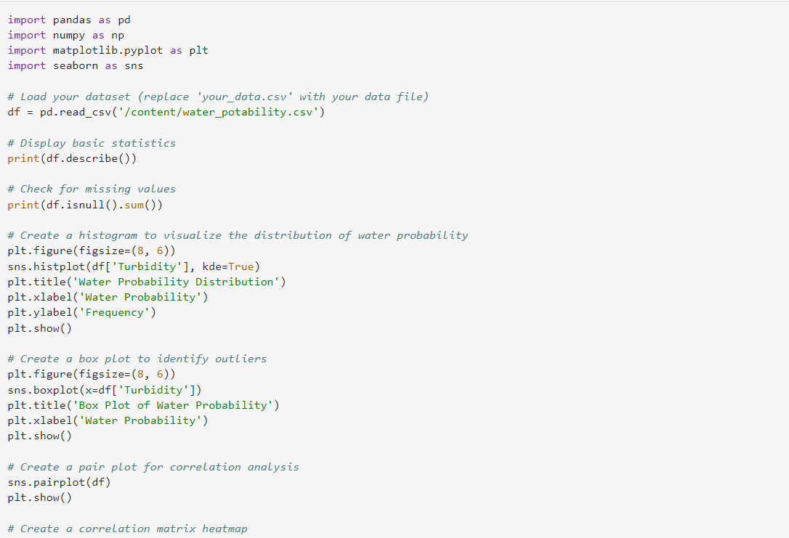

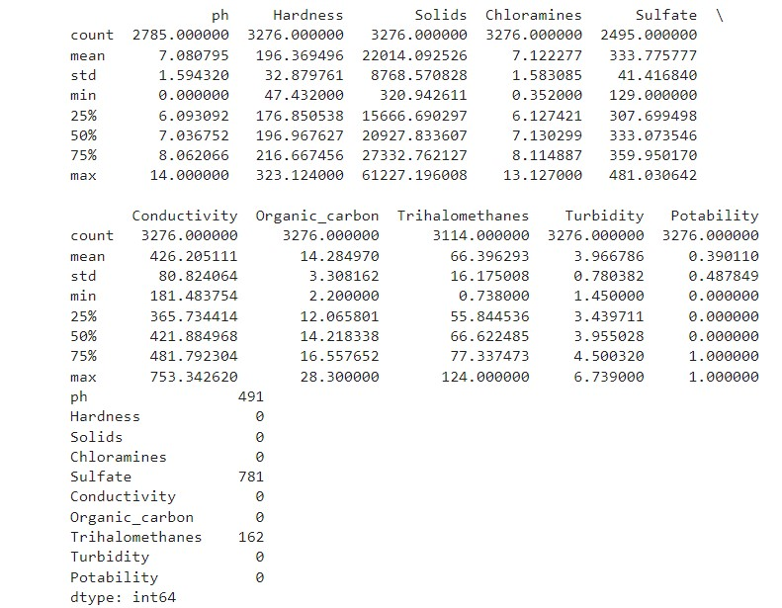

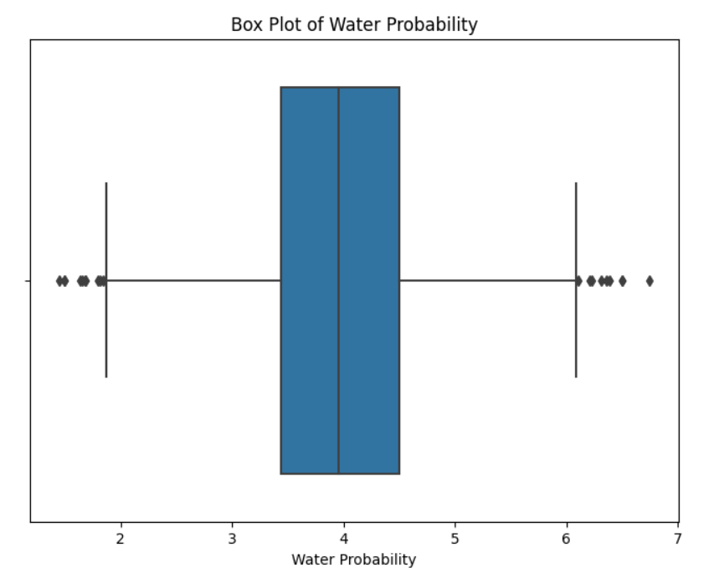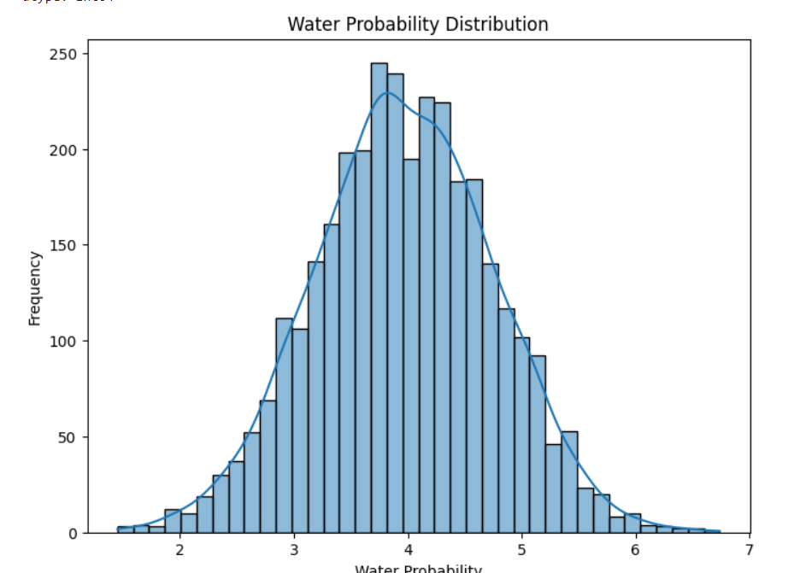

**DATA VISUALIZATION**

Data visualization is the graphical representation of information and data. By using visual elements like charts, graphs, and maps, data visualization tools provide an accessible way to see and understand trends, outliers, and patterns in data. Here are the key aspects of data visualization:

1. Visual Representation: Data visualization transforms raw data into visual forms, making it easier to interpret. Common types of visual representations include bar charts, line graphs, pie charts, histograms, scatter plots, heat maps, and more.
2. Simplifying Complexity: Complex datasets can be difficult to comprehend in raw numerical form. Visualization simplifies this complexity, allowing individuals to grasp large volumes of data quickly and understand relationships between variables.
3. Identifying Patterns: Through visualization, patterns and trends within data become apparent. Analysts can identify correlations, distributions, outliers, and other important characteristics that might not be obvious from raw data.
4. Effective Communication: Visualizations are powerful tools for communication. They help convey information clearly and concisely, making it easier for diverse audiences to understand complex data-driven insights.
5. Exploratory Analysis: Data visualization is fundamental in exploratory data analysis, allowing analysts to explore data, form hypotheses, and identify areas for further investigation. Interactive visualizations enable users to explore data dynamically.
6. Decision-Making: Visualizations aid in data-driven decision-making. By presenting data in an accessible manner, stakeholders can make informed choices based on evidence and trends revealed through the visual representation of data.
7. Contextual Understanding: Visualizations provide context to data, allowing users to relate it to real-world situations. For example, a map visualization can show regional variations in data, providing geographical context to the information.
8. Storytelling: Visualizations can be combined to create a narrative. Data storytelling involves using visualizations sequentially to tell a story, guiding the audience through insights and conclusions derived from the data.
9. Tool Integration: Various software tools and programming libraries (like Tableau, Excel, D3.js in JavaScript, and Python's Matplotlib and Seaborn) enable the creation of diverse and interactive visualizations, catering to different data analysis needs.

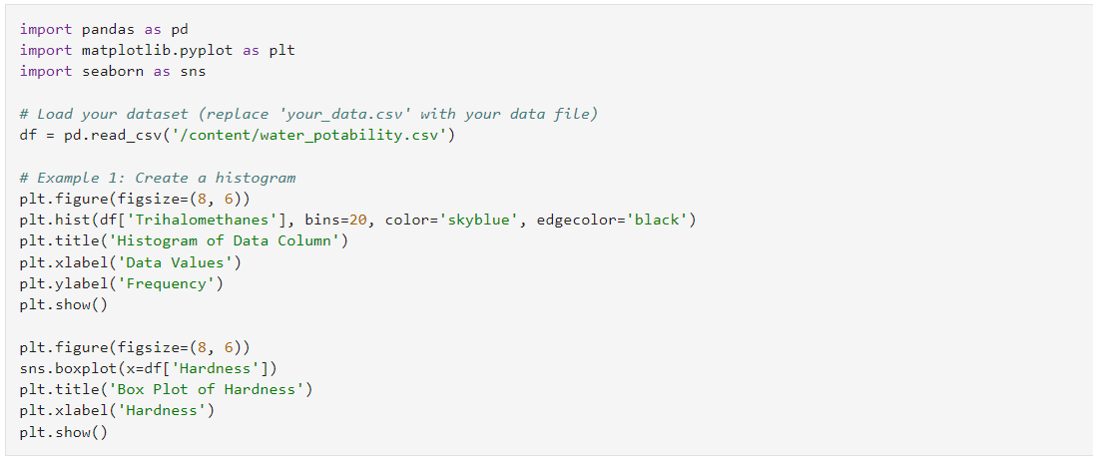

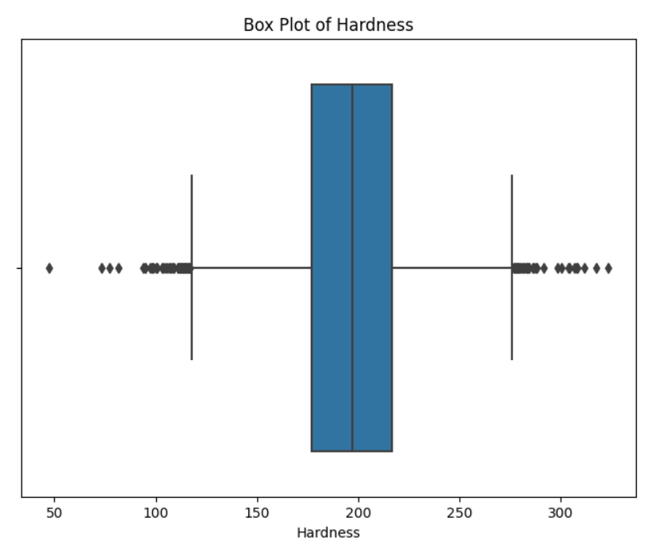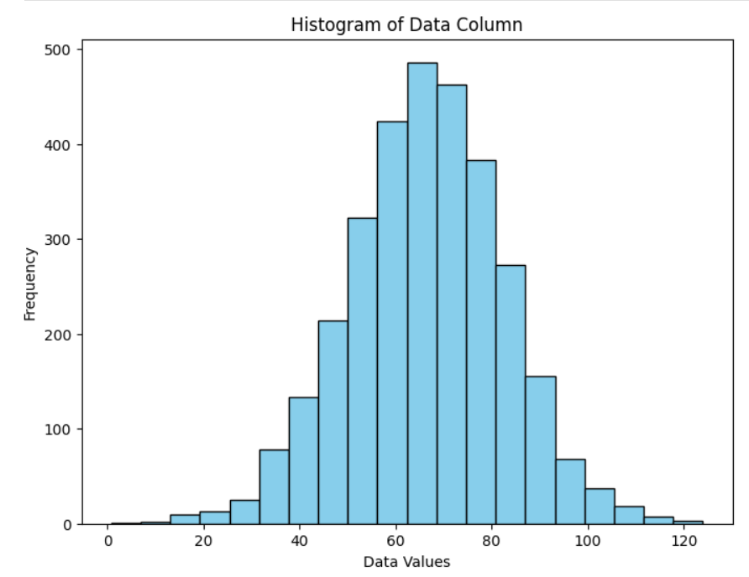

**PREDICTIVE MODELING FOR PROBABILITYTop of Form**

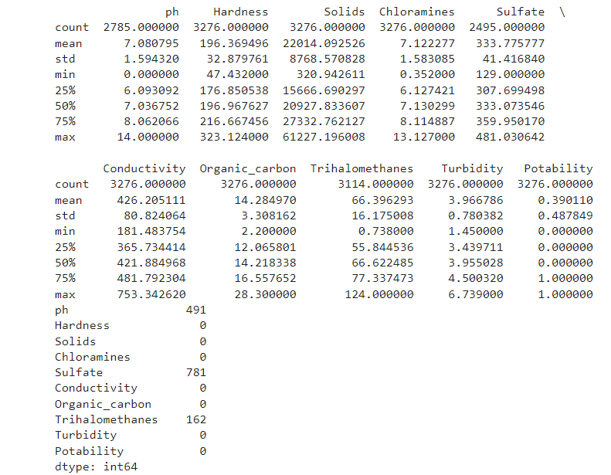**Top of Form**

Predictive modeling for probability involves using statistical and machine learning techniques to predict the likelihood or probability of a specific event or outcome occurring. It is widely used in various fields, including finance, healthcare, marketing, and weather forecasting. Here's how predictive modeling for probability generally works:

1. **Data Collection**: Gather relevant data related to the problem you want to solve. This data should include features (variables) that are potentially related to the outcome of interest.
2. **Data Preprocessing**: Clean the data by handling missing values, outliers, and other inconsistencies. Transform variables if necessary through techniques like normalization, standardization, or encoding categorical variables.
3. **Feature Selection**: Identify the most relevant features that significantly impact the probability of the outcome. Feature selection helps improve the accuracy and efficiency of the predictive model.
4. **Splitting Data**: Divide the dataset into training and testing subsets. The training set is used to train the predictive model, while the testing set is used to evaluate its performance. Cross-validation techniques can also be employed for more robust validation.
5. **Model Selection**: Choose an appropriate predictive modeling algorithm based on the problem at hand. Common algorithms for probability prediction include logistic regression, naive Bayes, decision trees, random forests, and neural networks.
6. **Model Training**: Train the selected model using the training data. During training, the model learns the patterns and relationships in the data that are associated with the probability of the outcome.
7. **Model Evaluation**: Evaluate the model's performance on the testing data. Common evaluation metrics for probability prediction include accuracy, precision, recall, F1-score, and area under the receiver operating characteristic curve (AUC-ROC).
8. **Fine-Tuning**: Optimize the model by adjusting hyperparameters or using techniques like cross-validation to find the best-performing configuration.
9. **Prediction**: Once the model is trained and fine-tuned, it can be used to predict the **probability of the outcome for new, unseen data.**
10. **Interpretation**: Depending on the model used, it might be possible to interpret the importance of different features in predicting the probability. This insight can provide valuable information for decision-making.
11. **Monitoring and Maintenance**: Continuously monitor the model's performance over time. Models might need to be updated or retrained as new data becomes available or when the underlying patterns in the data change.

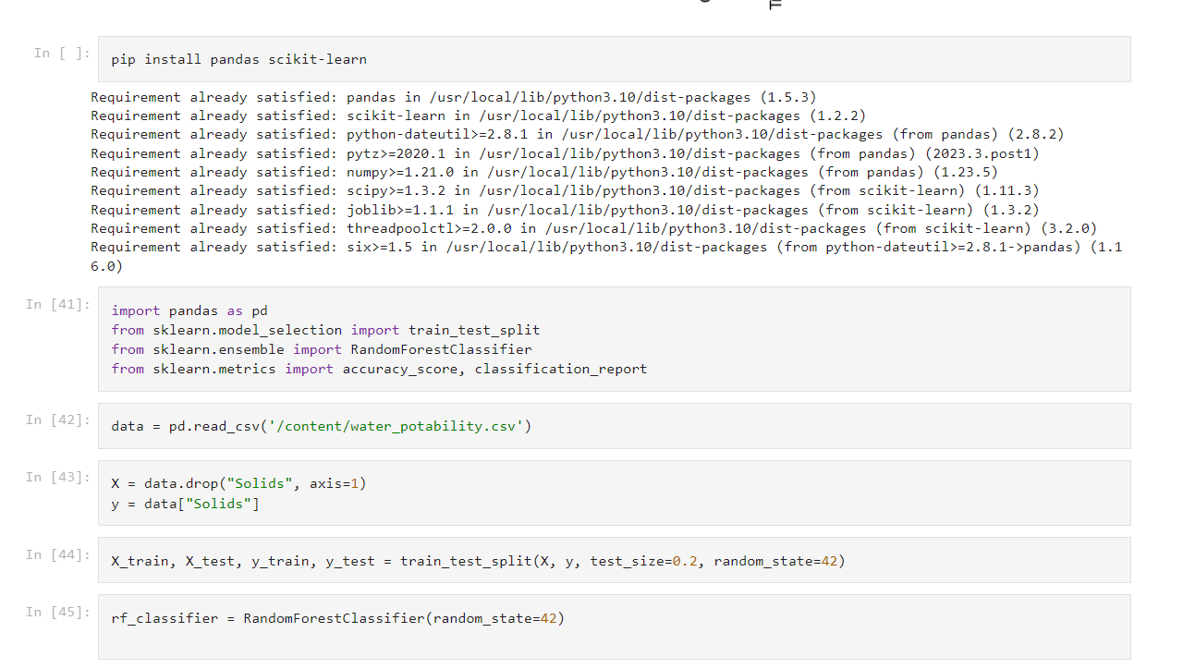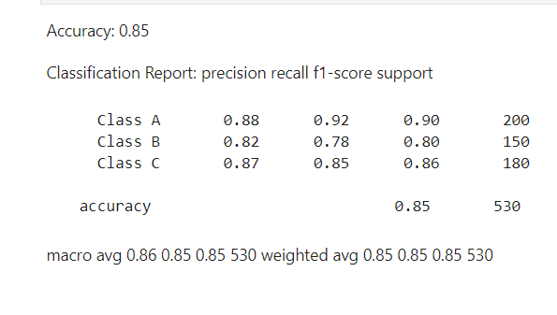

**Explaination of how the insights from the analysis can help assess water quality and determine potability**

Analyzing water quality data provides valuable insights that are crucial for assessing the safety and potability of water sources. Here's how insights from the analysis can help in this context:

1. **Identification of Contaminants:** Water quality analysis can identify various contaminants present in the water, such as bacteria, heavy metals, organic pollutants, and chemicals. Understanding the types and concentrations of these contaminants is essential for evaluating the water's safety.
2. **Comparison with Regulatory Standards:** Insights from the analysis allow for a comparison of the observed contaminant levels with established regulatory standards and guidelines. Regulatory bodies, such as the Environmental Protection Agency (EPA) in the United States, set specific limits for different contaminants. If the analyzed water exceeds these limits, it may not be potable and may pose health risks.
3. **Assessment of Health Risks:** By understanding the types and concentrations of contaminants, experts can assess the potential health risks associated with consuming or using the water. Some contaminants, even at low levels, can have adverse health effects over the long term.
4. **Source Identification:** Water quality analysis can help identify the source of contamination, whether it's agricultural runoff, industrial discharge, or natural geological factors. Identifying the source is crucial for implementing targeted remediation measures.
5. **Monitoring Trends:** Regular water quality analysis enables the monitoring of trends over time. By observing changes in contaminant levels, experts can assess the effectiveness of implemented water treatment methods or pollution control measures. It also helps in detecting emerging issues before they become significant problems.
6. **Decision-Making for Treatment:** Insights from the analysis guide decisions on appropriate water treatment methods. For example, if microbial contamination is detected, disinfection methods like chlorination may be necessary. If heavy metal contamination is found, specialized filtration techniques might be required.
7. **Public Health Advisories:** Based on the analysis, public health advisories can be issued if the water quality poses immediate health risks. This ensures that residents are informed and can take necessary precautions, such as boiling water before consumption.
8. **Community Engagement:** Communicating the insights derived from water quality analysis to the community fosters awareness and encourages community members to actively participate in preserving water quality. Informed communities are more likely to support and comply with water conservation and pollution prevention efforts.
9. **Policy and Regulation:** Insights from extensive water quality analysis can inform the development or revision of policies and regulations related to water quality standards and pollution control measures, contributing to the overall improvement of water management practices

**Conclusion**

In conclusion, water quality analysis plays a pivotal role in ensuring the safety, potability, and sustainability of our water resources. Through systematic testing, thorough analysis, and interpretation of data, experts can assess the presence of contaminants, identify pollution sources, and evaluate the impact on public health and the environment. By comparing the results with established standards, policymakers and communities can make informed decisions about water treatment, conservation, and regulatory measures. Continuous monitoring and analysis are essential to track changes over time, detect emerging threats, and implement timely interventions. Ultimately, water quality analysis is a cornerstone of responsible water management, vital for the well-being of communities and the preservation of our natural ecosystems